Sensory Evaluation Triangle Tes
Sensory Evaluation | Sensory Evaluation of food is a scientific method of analyzing and measuring individuals’ responses to food products as they perceive them through their senses.
Taste Panel Tests | - Acceptance or Preference Tests that determine how much panelists like that particular food or whether panelists prefer a particular food product over another.  - Difference or Discrimination Tests that determine whether panelists can detect difference between two or more food samples.  - Descriptive Analysis that determines how much do food products evaluated differ in a specific particular sensory attribute.
Triangle Test | - The Triangle Test is one of the most commonly used discrimination tests.  - Three samples are presented at the same time to the panelist: two are alike and one is different. The panelist is asked to indicate the odd sample.
Purpose of Triangle Test | - For determining that a perceptible difference results (triangle testing for difference).  - For determining that a perceptible difference does not result (triangle testing for similarity).  - Each group will design a Triangle Test for Difference on a juice product assuming there is a need to formulate an improved version of the juice.  - You will determine if a perceptible difference results between the original juice sample and the modified one. (Triangle Test for Difference).  - The panelists are the class members excluding the group members themselves.

Basic steps of Triangle Testing
I. Preparation of samples of your juice product | - Preparation of the modified juice sample from the original juice sample: either add sugar to the original juice sample or add water to the original juice sample. Assume your original juice sample is sample A. Assume the modified juice sample is sample B.  - Sequence in which samples are presented to panelists: Make duplicate of your original sample A and call it A’ and duplicate of your modified sample B and call it B’. Make different serving sequences for tasting the juice samples so as not to have carry-over effects due to tasting the samples in only one specific order: AA’B, ABA’, BAA’, BAB’, BB’A, ABB’  - Labelling the samples A, A’,B and B’:
II. Conducting Triangle Test on juice samples of all other groups | - Perform triangle test on all juice samples of all other groups making sure to taste the samples in the sequence indicated from left to right.  - Record your evaluation on the score sheet.  - Hand in the score sheet to the group representative and dispose of the cups when done.
III. Collecting data of the Triangle Test of your juice product | - Fill all results taken from score sheets in the grading table.  - Calculate TOTAL number of correct answers.

Data Analysis
Compare the TOTAL (for all types of juice) obtained to the numbers at probability levels say: 5% (0.05) and 1% (0.01), in the table of “Minimum Numbers of Correct Judgments to Establish Significance at Various Probability Levels for Triangle Test”
(n) is the number of panelists that conducted your test.
(n = number of all class members – number of your group members)
- If TOTAL obtained is equal or more than the number at the specified probability level then the purpose of the triangle test has been met (in your case, the panelists have been able to perceive a difference).
- If TOTAL obtained is less than the number at the specified probability level then the purpose of the triangle test has not been met (in your case, the panelists have not been able to perceive a difference).

Give an example of a situation in which you will use the triangle test for difference.
A company uses Stevia plant as a natural sweetener for its low calorie beverages. However, consumers complained about a bitter after taste. The company decides to change to a different supplier of Stevia sweetener and now wants to know if consumers can actually tell the difference between the current products and the modified ones.

Give an example of a situation in which you will use the triangle test for similarity.
A bakery was notified that the source from which they buy flour is shutting down. The bakery was then forced to use a different type of flour from a different source but without changing the overall quality and taste of the product. In this case, the bakery conducts a triangle test for similarity to make sure that the customers do not detect a difference in taste.

Why are different sequences used in presenting food samples to the panelists for assessment?
Different serving sequences are presented for tasting the juice samples so as not to have carry-over effects due to tasting the samples in only one specific order. In other words, the aim is to prevent the panelist from choosing the odd sample only because of the position or disposition. This way, the panelist responses would be more objective.

Why are random numbers used for labeling food samples?
The random 3-digit numbers are used to label the food to prevent any biases in the triangle test. Simple numbers are not used in order not to affect the choice of the panelist based on their preferences for a specific number. Thus, the random numbers will provide more objective results without biases.

Preparation of Bread

Types of Bread
Flour | Source of gluten.
Yeast | Leavening agent
Water | Dissolves all ingredients
Salt | Contributes to flavor  Favors action of amylase  Has strengthening effect on gluten
Sugar | Contributes to flavor  Source of fermentable substrate for the yeast  Yields a “browner” color bread. Softens the bread.
Powdered milk | Contributes to flavor  Improves bread texture
Shortening/ Olive Oil | Contribute to flavor  Lubricate gluten  Act as tenderizers  Improve bread texture
Arabic Bread
- Arabic bread from white flour
- Arabic bread from whole wheat flour
European Bread
- White Pan Bread
  - Full fermented white pan bread
  - Half fermented white pan bread
- Italian Bread
  - Italian bread from white flour
  - Italian bread from whole wheat flour

Basic Steps
- Preparation of Ingredients
- Preparation of dough: mixing specified ingredients in the Dough Mixer to obtain the dough.
Arabic Bread | flour, water, yeast and salt
White Pan Bread | flour, water, yeast, salt, sugar, powdered milk, shortening
Italian Bread | flour, water, yeast, salt, olive oil
- Bulk Fermentation
- The action of yeast on simple sugars. CO2 that will be trapped in gluten films which causes bread to leaven (alcohol produced during fermentation will evaporate).
- Fermentation is done by all groups in the incubator at a temperature of 40ºC which is the optimal temperature for the yeast activity.

- Punching
- Replenishes the supply of O2 needed for the action of the yeast
- Uniformly distributes yeast cells throughout the dough
- Uniformly distributes temperature throughout the dough
- Keeps the films of gluten from being overstretched
- Subdivides & therefore increases the number of the gas cells which have enlarged during the fermentation period
- Punching is done by the European Bread groups by knocking back the dough by hand followed =by allowing the dough to rise by fermenting in the incubator.

- Rounding: Dough is rounded into balls then allowed to ferment further in the incubator.
- Formation of smooth dough balls is essential because original shape of dough allows CO₂ to escape.
- Rounding of the dough is done by all groups.

- Shaping: Dough balls are molded into the final shape of the different types of bread.
- Arabic Bread: Sheets
- White Pan Bread: Rectangular shape to fit the bread pan
- Italian Bread: Oval strips
- Proofing
- Proof is the fermentation period between molding (shaping) and baking.
- It allows the dough to rise again to achieve a light baked product.
- Baking

- Development of flavors
- Gluten coagulation & starch gelatinization
- Partial dehydration
- Crust formation due to surface dehydration
- Changes of color and crust darkening
- Expansion and evolution and of gases
- Formation of pocket in Arabic bread
- Arabic bread: 500ºC
- European bread: 230ºC in the regular oven

Why are the extraction rates of whole wheat flour and white flour different?
The extraction rate is the percentage of wheat that is made into flour. The higher the extraction rate, the more of the bran, germ and tougher outer layers of endosperm the flour has. Whole wheat flour is by definition 100% extraction, since it contains all the parts of the kernel. White flour, on the other hand, has a lower extraction rate as the bran and germ have been removed in the milling process.

What is the effect of fermentation on different bread quality factors?
During fermentation, yeast cells cause a series complex biochemical. In turn, it achieves the following: improves dough handling characteristics, enhances gas retention in doughs, enhances finished product texture, provides desirable flavor, and extends shelf-life of final product.

What is malt? What is the purpose of its use in bread making?
Malt is germinated cereal grains that have been dried. Malting grains develops the enzymes required for modifying the grain's starches into various types of sugar. Amylase and sucrose, for instance, do four important things:
- Provide nutrients for yeast
- Facilitate the conversion of starch into sugars
- The extra sugar also boosts initial yeast
- Sugar also softens bread since it’s a substrate for yeast the CO2 released will soften bread

What is the effect of the addition of calcium propionate in bread making?
Calcium propionate is an antimicrobial agent. It is effective in preventing microorganisms and mold growth without affecting the yeast activity. This helps extend the shelf life of bread products.

What is bread staling? What are the factors that enhance it?
Staling is the decrease in the palatability of bread that does not include microbial contamination. It is a change in both chemical and physical attributes that give bread products a dry, leathery texture. Factors that can enhance staling include:
- Ingredients: affect the crumb firming & moisture changes. Any ingredient that increases absorption usually aids in the inhibition of staling & any ingredient that contributes to inc. loaf volume improves the crumb softness.
- Processing: affects loaf volume and initial crumb softness.
- Packaging: affects moisture changes, crust textures and flavor.
- Temperature: refrigeration favors crumb firming but high temperatures affect color and flavor.
- Emulsifiers: increase crumb softness and strengthen dough.
- Enzymes: slower the rate of crumb firming by slowing the rate of moisture change from crumb to crust.

What is the best way of storage of bread?
The best way to keep bread at its best is to freeze it for longer-term storage.

Preparation of Cheese
Cheese can be defined as a product made from the curd. The curd that is produced by coagulating the milk protein casein w/ enzyme: with/without an acid or with/without further treatment of the curd by heat, pressure, salt and ripening.
Basic steps:
- Preparation of ingredients
Milk | principle ingredient
Rennin Enzyme | Rennin is obtained form the 4th stomach of young calves. Optimum coagulation temperature for most cheeses is 36-40ºC.
Calcium Chloride | CaCl₂ is a food additive that decreases pH and enhances milk coagulation after the addition of the enzyme therefore yielding a firmer curd.
Brine | 10% brine will be prepared by each group, during curd formation, to store cheese (I. Preparation of Ingredients step 2)

- Preparation of the curd
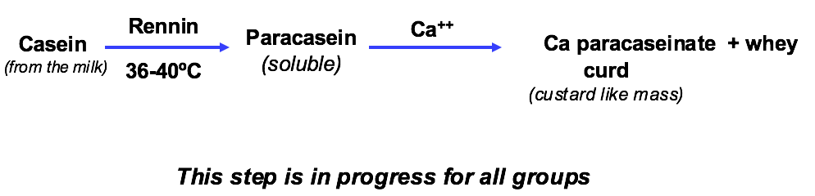
- Cutting the curd
The curd will be cut with a knife into small cubes and left for few minutes to allow more extraction of whey from it.

- Pressing the curd
    - Curd pieces will be gently transferred into cheesecloth fitted on strainers.
    - Curd will then be pressed in the cheese press to give the Akkawi Cheese.
    - Pressing determines the final moisture content and shape of the cheese. (Moisture content of Akkawi cheese is in general around 51%).
    - Yield of Akkawi cheese is in general around 1 kg / 5 lit milk.

- Brining the cheese
Different Akkawi cheeses prepared in the Pilot Plant will be stored in around 10% brine.

Why is the milk heated to 36-40°C in cheese making and maintained at that temperature?
Milk heated to 36-40°C in cheese making and maintained at that temperature as it is the optimum coagulation temperature for most cheeses.

Why is the curd cut into small cubes?
Curd is cut into small cubes to enhance whey and curd separation by increasing surface area.

Why is the cut curd left for few minutes after cutting?
Curd is left for a few minutes after cutting to allow for whey (liquid component) and curd (solid component) separation.

Preparation of Pickles

- Cucumber pickles are cucumbers that have been preserved in pickling solution.
- Cucumbers used for pickling must be of good quality, immature, un-bruised, small in size (around 10 cm) and must not have dead flowers.
- Pickling solution is usually made up of water, coarse salt and vinegar.
- Coarse salt & vinegar are natural and inexpensive ingredients used for their preservation effect and flavor.
- Proper coarse salt concentration must be used in pickling:
Too strong concentration toughen & shrink cucumber
Too weak concentration spoilage will occur
- Addition of other flavoring ingredients, such as herbs and spices, to the pickling solution is also common.

Basic Steps
- Preparation of pickling solution
    - Unfermented Pickles
      - 2 liters water, 1 liter vinegar and 120 g coarse salt
      - 2 liters water, 1 liter vinegar and 40 g coarse salt
    - Fermented Pickles
      - 4 liters water, 320 g coarse salt and 12 g lactic acid
- Preparation of cucumbers
      - Clean cucumbers and remove dead flowers
      - Cut the cucumbers cross-sectionally
        - Dry salted cucumbers packed with boiling pickling solution: Soak cucumbers in coarse salt overnight (Salt draws water from the cucumbers by the process of osmosis. Pickles tend to shrink, dehydrate, and become harder).
        - Wet salted cucumbers packed with boiling pickling solution: Soak cucumbers in 8% brine overnight (Some fermentation starts during soaking but will stop when optimal conditions cease to exist. Texture of pickles will be better than the dry salted ones and no shrinking will occur).
        - Fermented cucumbers packed with its fermentation brine: Soak cucumbers for a week in 8% brine (optimal concentration for naturally occurring lactic acid bacteria LAB). Lactic acid is added to enhance activity of LAB. Adjust brine concentration daily by Baumé hydrometer to 8% to maintain the optimal conditions of the LAB for fermentation (Fermentation takes place and goes on as long as the optimal conditions for LAB are maintained. Salt in the brine draws out sugar and water from the cucumbers).
- Packing of cucumbers
  - Fresh cucumbers packed with boiling pickling solution: Place cucumbers tightly in one sterile jar, pour on them the pickling solution, close tightly, invert jar and store at RT. No fermentation occurs because the boiling pickling solution stops microorganisms growth.
  - Fresh cucumbers packed with cold pickling solution: Place cucumbers tightly in one sterile jar, pour on them the pickling solution, close tightly and store at RT. Some slow fermentation may start but will stop when salt concentration decreases.
  - Sliced fresh cucumbers packed with boiling pickling solution: Place cucumbers tightly in one sterile jar, pour on them the pickling solution, close tightly, invert jar and store at RT. No fermentation occurs because the boiling pickling solution stops microorganisms growth. Texture of pickles will be mushier.
  - Dry salted cucumbers packed with boiling pickling solution: The following day: wash cucumbers from salt or brine, place them tightly in one sterile jar, pour on them the boiling pickling solution, close tightly, invert jar and store at RT. No fermentation occurs because the boiling pickling solution stops growth of microorganisms.
  - Wet salted cucumbers packed with boiling pickling solution: The following day: wash cucumbers from salt or brine, place them tightly in one sterile jar, pour on them the boiling pickling solution, close tightly, invert jar and store at RT. No fermentation occurs because the boiling pickling solution stops growth of microorganisms.
  - Fermented cucumbers packed with its fermentation brine: After one week: wash cucumbers, place them tightly in one sterile jar, pour on them the boiling soaking brine, close tightly, invert jar and store at RT. Fermentation will stop because the boiling pickling solution will stop growth of microorganisms.

What physical changes take place in cucumbers during pickling?
Cucumbers are pickled to extend their shelf life and for preservation. Pickling of cucumbers will cause the color and texture of the cucumber to change. The texture of the cucumber when pickled may shrink depending on the method used. Furthermore, the color will also change from green to yellowish/ olive green and the taste will change as well.

Why is it recommended to use coarse salt rather than ordinary salt in pickling?
- It has more impact on the flavoring of the cucumber pickles and their preservation.
- It is natural and inexpensive.
- Ordinary salt may be iodinated and iodine might color the pickles

What is the role of lactic acid in fermented pickles?
Lactic acid bacteria are relatively salt-tolerant, whereas some of the less desirable bacteria aren't. Lactic acid is used to strengthen the function of LAB. LAB digests the sugars in the cucumber to give out lactic acid. LA, a source of acidity, will give the sour taste that will be in the cucumber, will remove sugar that bacteria will feed on, and controls the spread of microbes. Therefore, cucumbers are reserved.

What is the effect of the addition of CaCl2 to pickles?
Calcium Chloride is a firming agent that can be used in pickling. CaCl2 will help to maintain the crispiness in the preserving process. It can also be used as an additive to add to the brine giving the cucumber a salty taste, therefore, not needing to add sodium.

What is scum in pickles? What is its effect on pickles?
Scum is a layer of yeast and/or mold that feeds on the acid. Scum may be formed if cucumbers are not fully covered with the brine solution or the container is not closed tightly and properly. Scum may destroy the physical appearance of the pickles. It also decreases the acid concentration in the pickling solution resulting in improper processing resulting in the spoilage of the cucumbers.

Why are bloaters formed in pickles? How are they treated?
Bloaters are the pickles that float on the brine solution or are hollow due to the formation of gas inside the pickle. They may result from gaseous fermentation caused by yeasts. The growth of the fermentable species of yeast can be controlled by the addition of sorbic acid or its sodium salt, or by the inhibition of gas-forming lactic acid bacteria. To prevent the formation of bloaters:
- pierce the cucumber
- purge carbon dioxide away with nitrogen gas. Nitrogen does not cause undesirable reactions nor does it stimulate aerobic microbes.
- If cucumbers are large, use smaller ones
- Always keep the proper strength of the brine solution
- Start pickling within 24 hours after gathering
Bloaters are not a complete loss since they may be used in cut pickle and relish products at an economic loss of about 50%.

Preparation of Ketchup

Basic Steps
- Blanching tomatoes: Blanching is a short heat treatment performed on vegetables and fruits mainly to destroy spoilage enzymes. It also softens tissues, prevents development of off-flavors and odors, and improves physical properties such as appearance, texture (consistency) and color. Quarter tomatoes; steam blanch the quartered tomatoes simultaneously in the steam blancher.
- Pulping blanched tomatoes: Pulping blanched tomatoes separates the tomato pulp in tomatoes from the skin and other extraneous material.
- Blanched tomatoes will be pulped simultaneously in the Pulper Finisher.
- Take 1 kg tomato pulp and proceed to cook the tomato pulp (step IV).
- Preparation of Ingredients
- Tomato pulp
- Spices such as cloves, black pepper, cinnamon and paprika along with salt, onion and garlic will be placed in a tightly closed bag and added to the tomato pulp at the beginning of the cooking step.
- Sugar is added in two stages, during cooking of the tomato pulp, in order to allow it to dissolve completely and to avoid its being caramelized.
- Xanthan Gum will be mixed with sugar and sprinkled on the boiling tomato pulp to avoid its forming lumps.
- Vinegar will be added few minutes before finishing the cooking step as acetic acid of vinegar is volatile.
- Cooking tomato pulp: Cooking tomato pulp with other ingredients will be done until TSS is 20-25%.
- TSS (Total Soluble Solids) is a value that is used to verify that a product has reached a specified consistency. TSS is measured by the Refractometer.
- Ketchup must have a uniform and smooth texture to have a “good finish”.
- Filling tomato ketchup into bottles: Filling finished tomato ketchup will be done into narrow necked glass bottles.
- If ketchup is sealed at a temperature of 85ºC or more, then no further heating is necessary. Otherwise, thermal processing of ketchup bottles is done at 100ºC.
- Ketchup and other tomato products being high acid foods (pH<4.5) do not need retort sterilization (high temperature 121ºC and high pressure 15 psi) since the main microorganism that causes flat sour spoilage in tomato products is Bacillus thermoacidurans which is killed at 100ºC.

Why are tomatoes blanched prior to pulping in the preparation of ketchup?
Tomatoes are blanched to destroy spoilage enzymes & reduce microorganisms. It also softens tissues, prevents development of off-flavors & odors, & improves physical properties such as appearance, consistency and color.

Why is one third of the sugar amount added at the beginning of the cooking step?
Sugar is added in two stages in order to allow it to dissolve completely and to avoid its being caramelized.

What is the role of vinegar in ketchup preparation?
Vinegar is added mainly to reduce the PH of ketchup and thus promoting longer preservation. In addition it gives the ketchup a more sour taste.

What is the effect of the addition of xanthan gum in ketchup preparation?
Xanthan gum is added to improve the consistency and viscosity of ketchup.

Preparation of Preserved Fruit Products I
- Preserved Fruit Products are gels or gel-like products prepared from fruits or fruit juices and a sweetener(s).
- Pectin and food acids are usually added to obtain a successful gel.
- The three essential ingredients the sweetener, the pectin and the food acids are concentrated with the fruits or fruit juices by heating till the desired TSS. Upon cooling the gel will form.

Basic Steps
- Preparation of ingredients
  - Apple Jelly: Apple juice, Sugar, HM pectin, Critic acid
  - Orange marmalade: Orange juice, Lemon juice, Orange peels, Sugar, HM pectin, Citric acid
  - Orange Syrup & Citrus Syrup: Citrus juice, Sugar, Citric acid
  - Apple & Strawberry Preserve in Syrup: Fruit (apple or strawberry), Water and sugar, Citric acid

- Heating the fruit juice
  - Apple Jelly: Heat apple juice
  - Orange marmalade: heat the orange and lemon juice with the orange peels
  - Orange Syrup & Citrus Syrup: Heat the fruit juices
  - Apple & Strawberry Preserve in Syrup: Heat the water

- Addition of sugar: amount of sugar added by different groups depends on sugar content of the fruit (%TSS of fruit) which varies depending on fruit type.

- Addition of pectin

  - Apple Jelly: Slow
  - Orange marmalade: Rapid
  - Orange Syrup & Citrus Syrup: No pectin
  - Apple & Strawberry Preserve in Syrup: No pectin
- Slow set pectin sets at around 55°C. Rapid set pectin sets at around 85°C.
- Quantity of pectin added is 1-2% of the weight of the fruits/fruit juices.
- Heating to attain the desired TSS
- All groups will heat the fruit/sugar/pectin mixture with continuous stirring until the desired TSS is reached.
- When sucrose is used, a generally accepted TSS level is 65 - 68%
- At this concentration the boiling temperature is 4-5°C above the boiling point of water.
- Addition of food acids
- ensure proper gel formation
- prevent sucrose crystallization
- aid in preservation of the product
- Citric acid, tartaric acid malic acid are common food acids used in preserved fruit products.

- Filling the finished product
- Apple jelly, orange marmalade, apple preserve in syrup and strawberry preserve in syrup will be filled in jars.
- Orange syrup and citrus syrup will be filled in bottles.
- If finished product is sealed at a temperature of 85ºC or more, then no further pasteurization is necessary.

Why is rapid-set pectin used in the preparation of marmalade?
Rapid-set pectin is used in the preparation of marmalade to promote the suspension of orange peel in the product and not allowing it to float at the top or sink to the bottom.

Why are sealed glass jars / bottles of preserved fruit products inverted for 5 minutes?
Sealed glass jars and bottles of preserved fruit products are inverted for 5 minutes to sterilize the cover and bottle neck of either container.

Why is there no need for pasteurization when preserved fruit products are sealed at temperature above 85 C?
There no need for pasteurization when preserved fruit products are sealed at temperature above 85C because they are high acid products.

Why is ascorbic acid sometimes added to preserved fruit products?
Ascorbic acid is sometimes added to preserved fruit products to lower PH and thus improve preservation, prevent sucrose crystallization and promote gel formation.

Preparation of Preserved Fruit Products II

Jams
- The principle of gel formation involving the three essential ingredients: sweetener, pectin and food acids in addition to the fruit and/or fruit juice will also be applied in jam preparation.
- Preparation of jam will be done using different types of sweeteners.

Basic Steps
- Preparation of ingredients
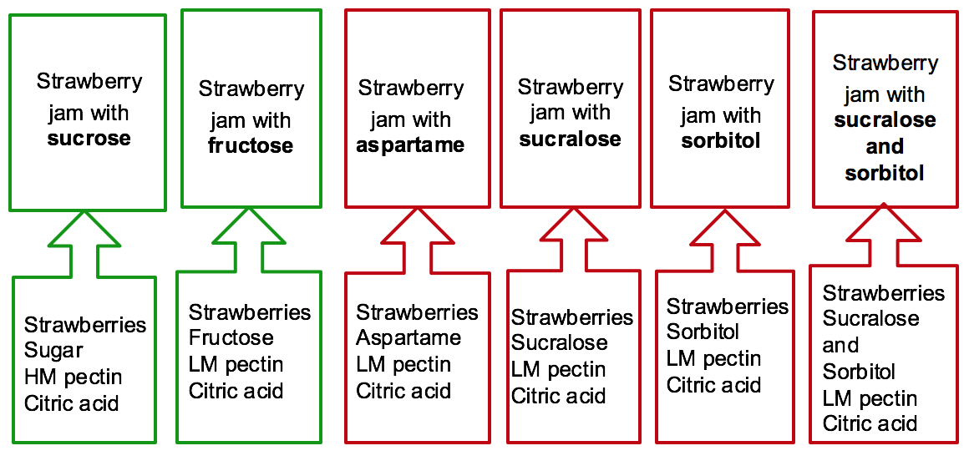
- Heating fruits with (or without) the sweetener
- Amount of sweetener added
- When using sucrose, fruit:sucrose ratio is 1:1
- When using other sweeteners, the ratio changes and the manner in which the sweetener is added is modified depending on the sweetener's relative sweetness to sucrose.
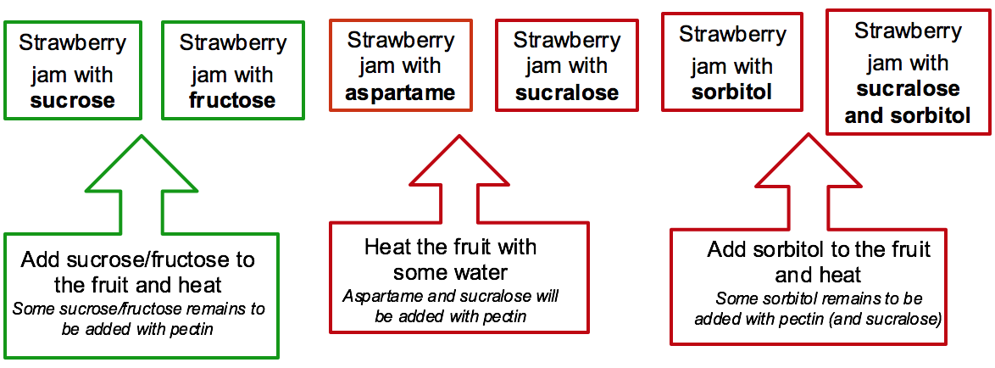

- Addition of pectin
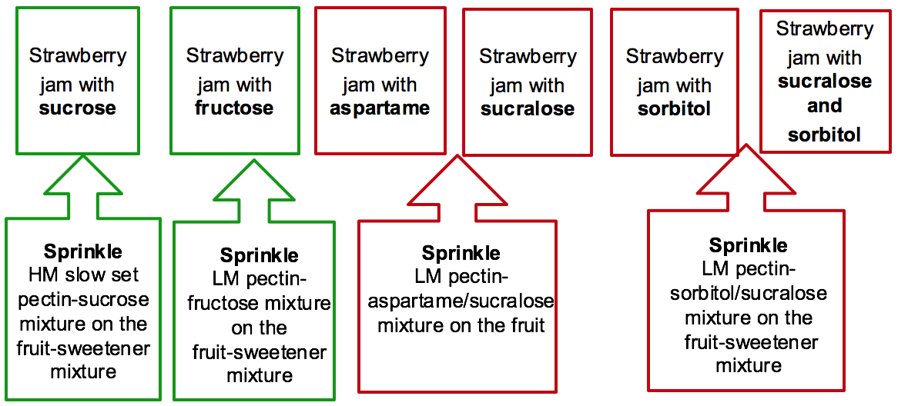
- Heating to attain the desired TSS
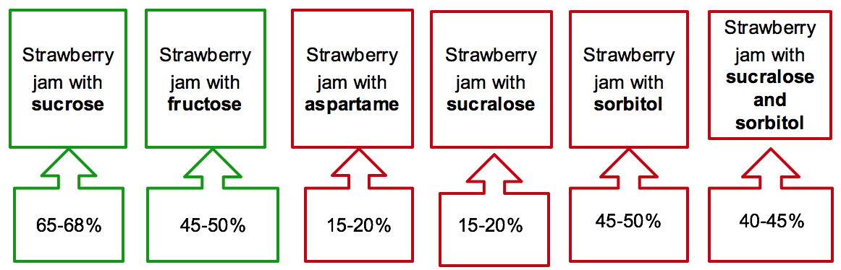

- Addition of food acids: Citric acid is added to ensure proper gel formation and prevent crystallization.

- Filling jam into jars: If strawberry jam jars are sealed at a temperature of 85ºC or above then no further pasteurization is necessary otherwise jars must be pasteurized in boiling water for 30 minutes.

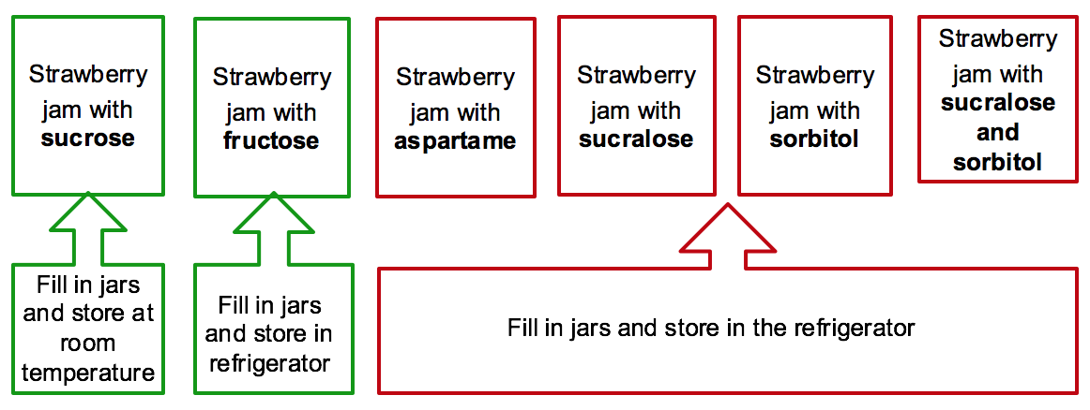

What happens if strawberries have been soaked in sugar overnight prior to jam preparation?
Soaking strawberries in sugar will soften the strawberries and contribute to a rich and sweet flavor.

Give examples of fruits rich in pectin.
Pears, apples, oranges, plums and guavas.

When is it necessary to add pectin in gel preparation?
Pectin is added when we are aiming for a larger product yield. Pectin serves as a thickening agent and helps in the formation of a gel, especially in jams made with low pectin fruits or artificial sweeteners.

Why are jams prepared with artificial sweeteners stored in the refrigerator? What is their shelf life when stored in the refrigerator?
The absence of natural sugar eliminates its preservation effect, thus jams with artificial sweeteners have a lower shelf life as compared to those made with sucrose. Jams made with artificial sweeteners last for 3-4 weeks in the refrigerator.

Preparation of Food Emulsions
- Food emulsions consist of two immiscible liquids (usually oil and water) with one of the liquids dispersed as small droplets (dispersed phase) in the other (continuous phase).
This state of emulsification between two immiscible liquids is maintained by emulsifiers.
Emulsifiers stabilize emulsions. Without emulsifiers, food emulsions will separate into water and oil layers.
- Lecithin is one of the most commonly used emulsifiers that can be found naturally in egg yolk and soybeans.
- There are two types of emulsions:
  - Oil in Water food emulsions (O/W) consist of oil droplets dispersed in water phase e.g. mayonnaise.
  - Water in Oil food emulsions (W/O) consist of water droplets dispersed in oil phase e.g. peanut butter.

Mayonnaise Basic Steps
- Preparation of ingredients
  - Regular Mayonnaise: vegetable oil, egg yolk, vinegar, mustard, salt, xanthan gum
  - Low Fat Mayonnaise: Vegetable oil, egg yolk, vinegar, mustard, salt, xanthan gum, corn starch, low fat yoghurt, lecithin
    - Low fat mayonnaise with eggs: Oil quantity is reduced. Egg yolk quantity is reduced. Corn starch is added to provide bulk lost by reduction of oil quantity
    - Low fat mayonnaise without eggs: Oil quantity is reduced. Egg yolk is not used. Corn starch and low fat yoghurt are added to provide bulk lost by reduction of oil quantity and absence of eggs. Lecithin is added to make up for the absence of lecithin from egg yolk.
  - Vegan Mayonnaise: Vegetable oil, vinegar, mustard, salt, xanthan gum, soymilk, tofu
    - Vegan mayonnaise with soymilk: Eggs are not used. Soymilk is used as a source of lecithin.
    - Vegan mayonnaise with tofu: Eggs are not used. Tofu, soybean curd, is used as a source of lecithin.
- Preparation of continuous phase: All ingredients, except the oil and the vinegar, are blended to form a homogeneous mixture (continuous phase: water phase).
- Addition of oil to form emulsion: Oil is added slowly in a thin line to the mixture with continuous mixing to achieve a good emulsion.
- Addition of vinegar: Vinegar is added for preservation and flavor.
- Filling into jars: Mayonnaise is filled into sterilized jars and stored at room temperature.

Peanut Butter Basic Steps
- Preparation of ingredients
  - Peanut Butter with and without Lecithin: Ingredients: roasted peanuts, peanut oil, salt, lecithin
  - Peanut Butter with Different Peanut Roasting Times (45 and 20 minutes): roasted peanuts, peanut oil, salt, lecithin
  - Peanut Butter with and without Peanut Oil: roasted peanuts, peanut oil, salt, lecithin
- Preparation of emulsion: All ingredients, except peanut oil, are grinded to form homogeneous mixture (continuous phase: oil phase) (dispersed phase: water phase)
- Addition of peanut oil: Peanut oil is added slowly to the mixture with continuous mixing to stabilize the emulsion
- Filling into jars: Peanut butter is filled into sterilized jars and stored at room temperature

What are the measures taken in mayonnaise preparation to ensure its safety?
To ensure its safety of prepared mayonnaise, there should not be any favorable conditions for microorganisms to grow. Thus, it should be prepared with acidic ingredients, such as vinegar and lemon juice, pasteurized eggs and salt, which contribute to the unfavorable conditions for microbial growth. Strict quality control procedures must also be implemented when manufacturing mayonnaise to further prevent the growth of bacteria.

Why is mayonnaise stored at room temperature before opening the jar?
Mayonnaise is stored at room temperature before opening the jar because since it is sterilized and preserved by the use of acidic ingredients and salt, bacteria cannot grow on it unless it is exposed, which is when the jar is opened.

Why are peanuts roasted in peanut butter preparation?
Peanuts are roasted to produce favorable color, flavor, and texture. An additional purpose of roasting is making the skin removal easier. Moreover, this procedure extends the peanut butter’s shelf life as it reduces the water content and thus the water activity of peanuts.

Why is peanut butter stored at room temperature before opening the jar?
Peanut butter is stored at room temperature before opening the jar because it is sterilized and remains so as long as the jar is still closed. Before opening the jar, roasted peanuts and the addition of salt help preserve the product and thus it cannot be contaminated unless exposed to the bacteria outside.

